CS 255 System Design Document

UML Diagrams

UML Use Case Diagram
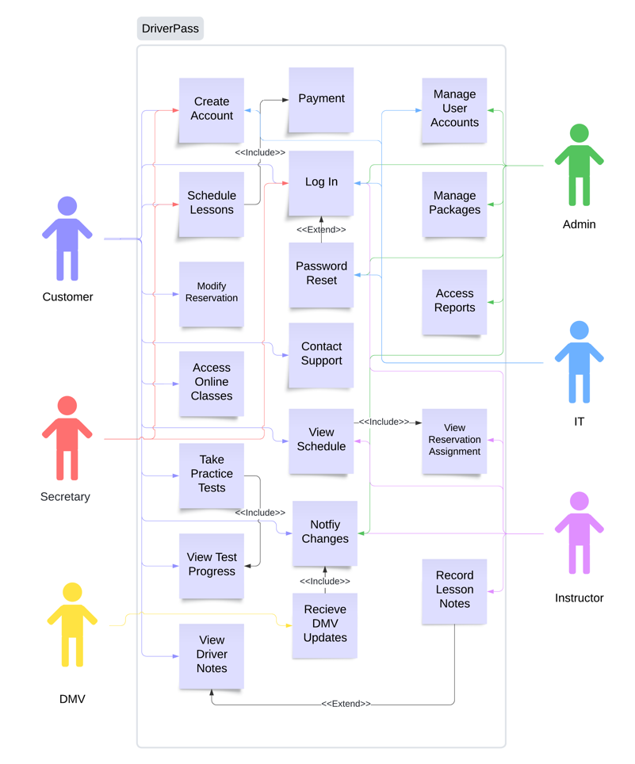

UML Activity Diagrams
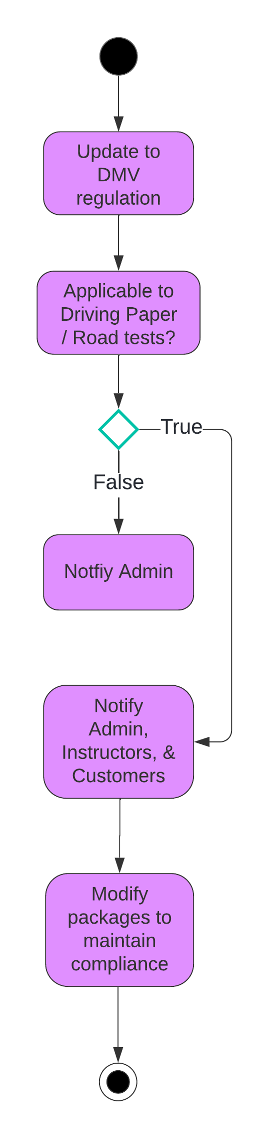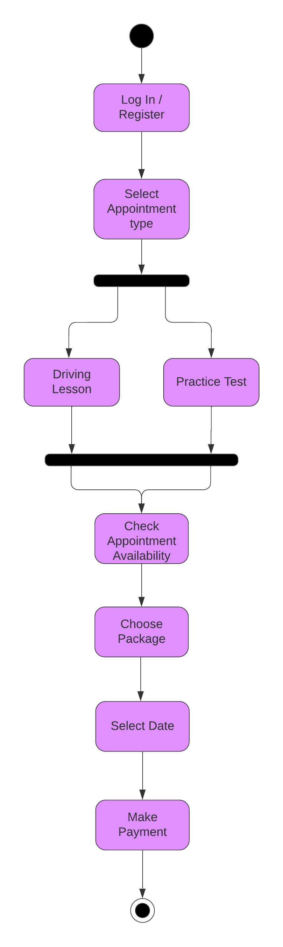

UML Sequence Diagram
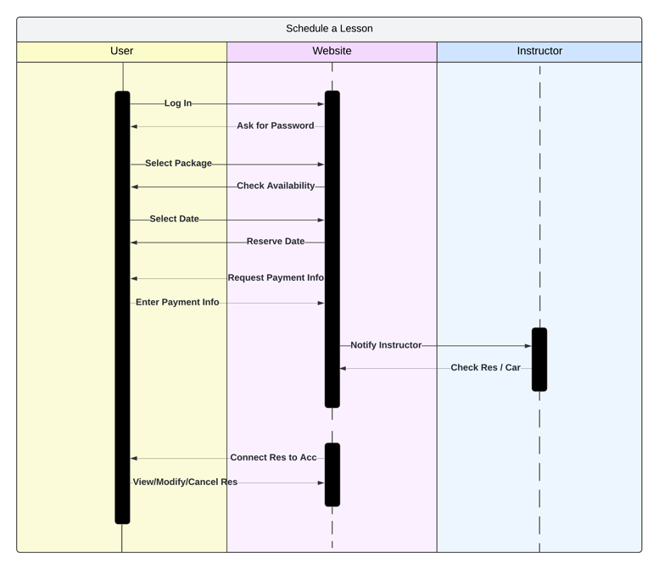

UML Class Diagram
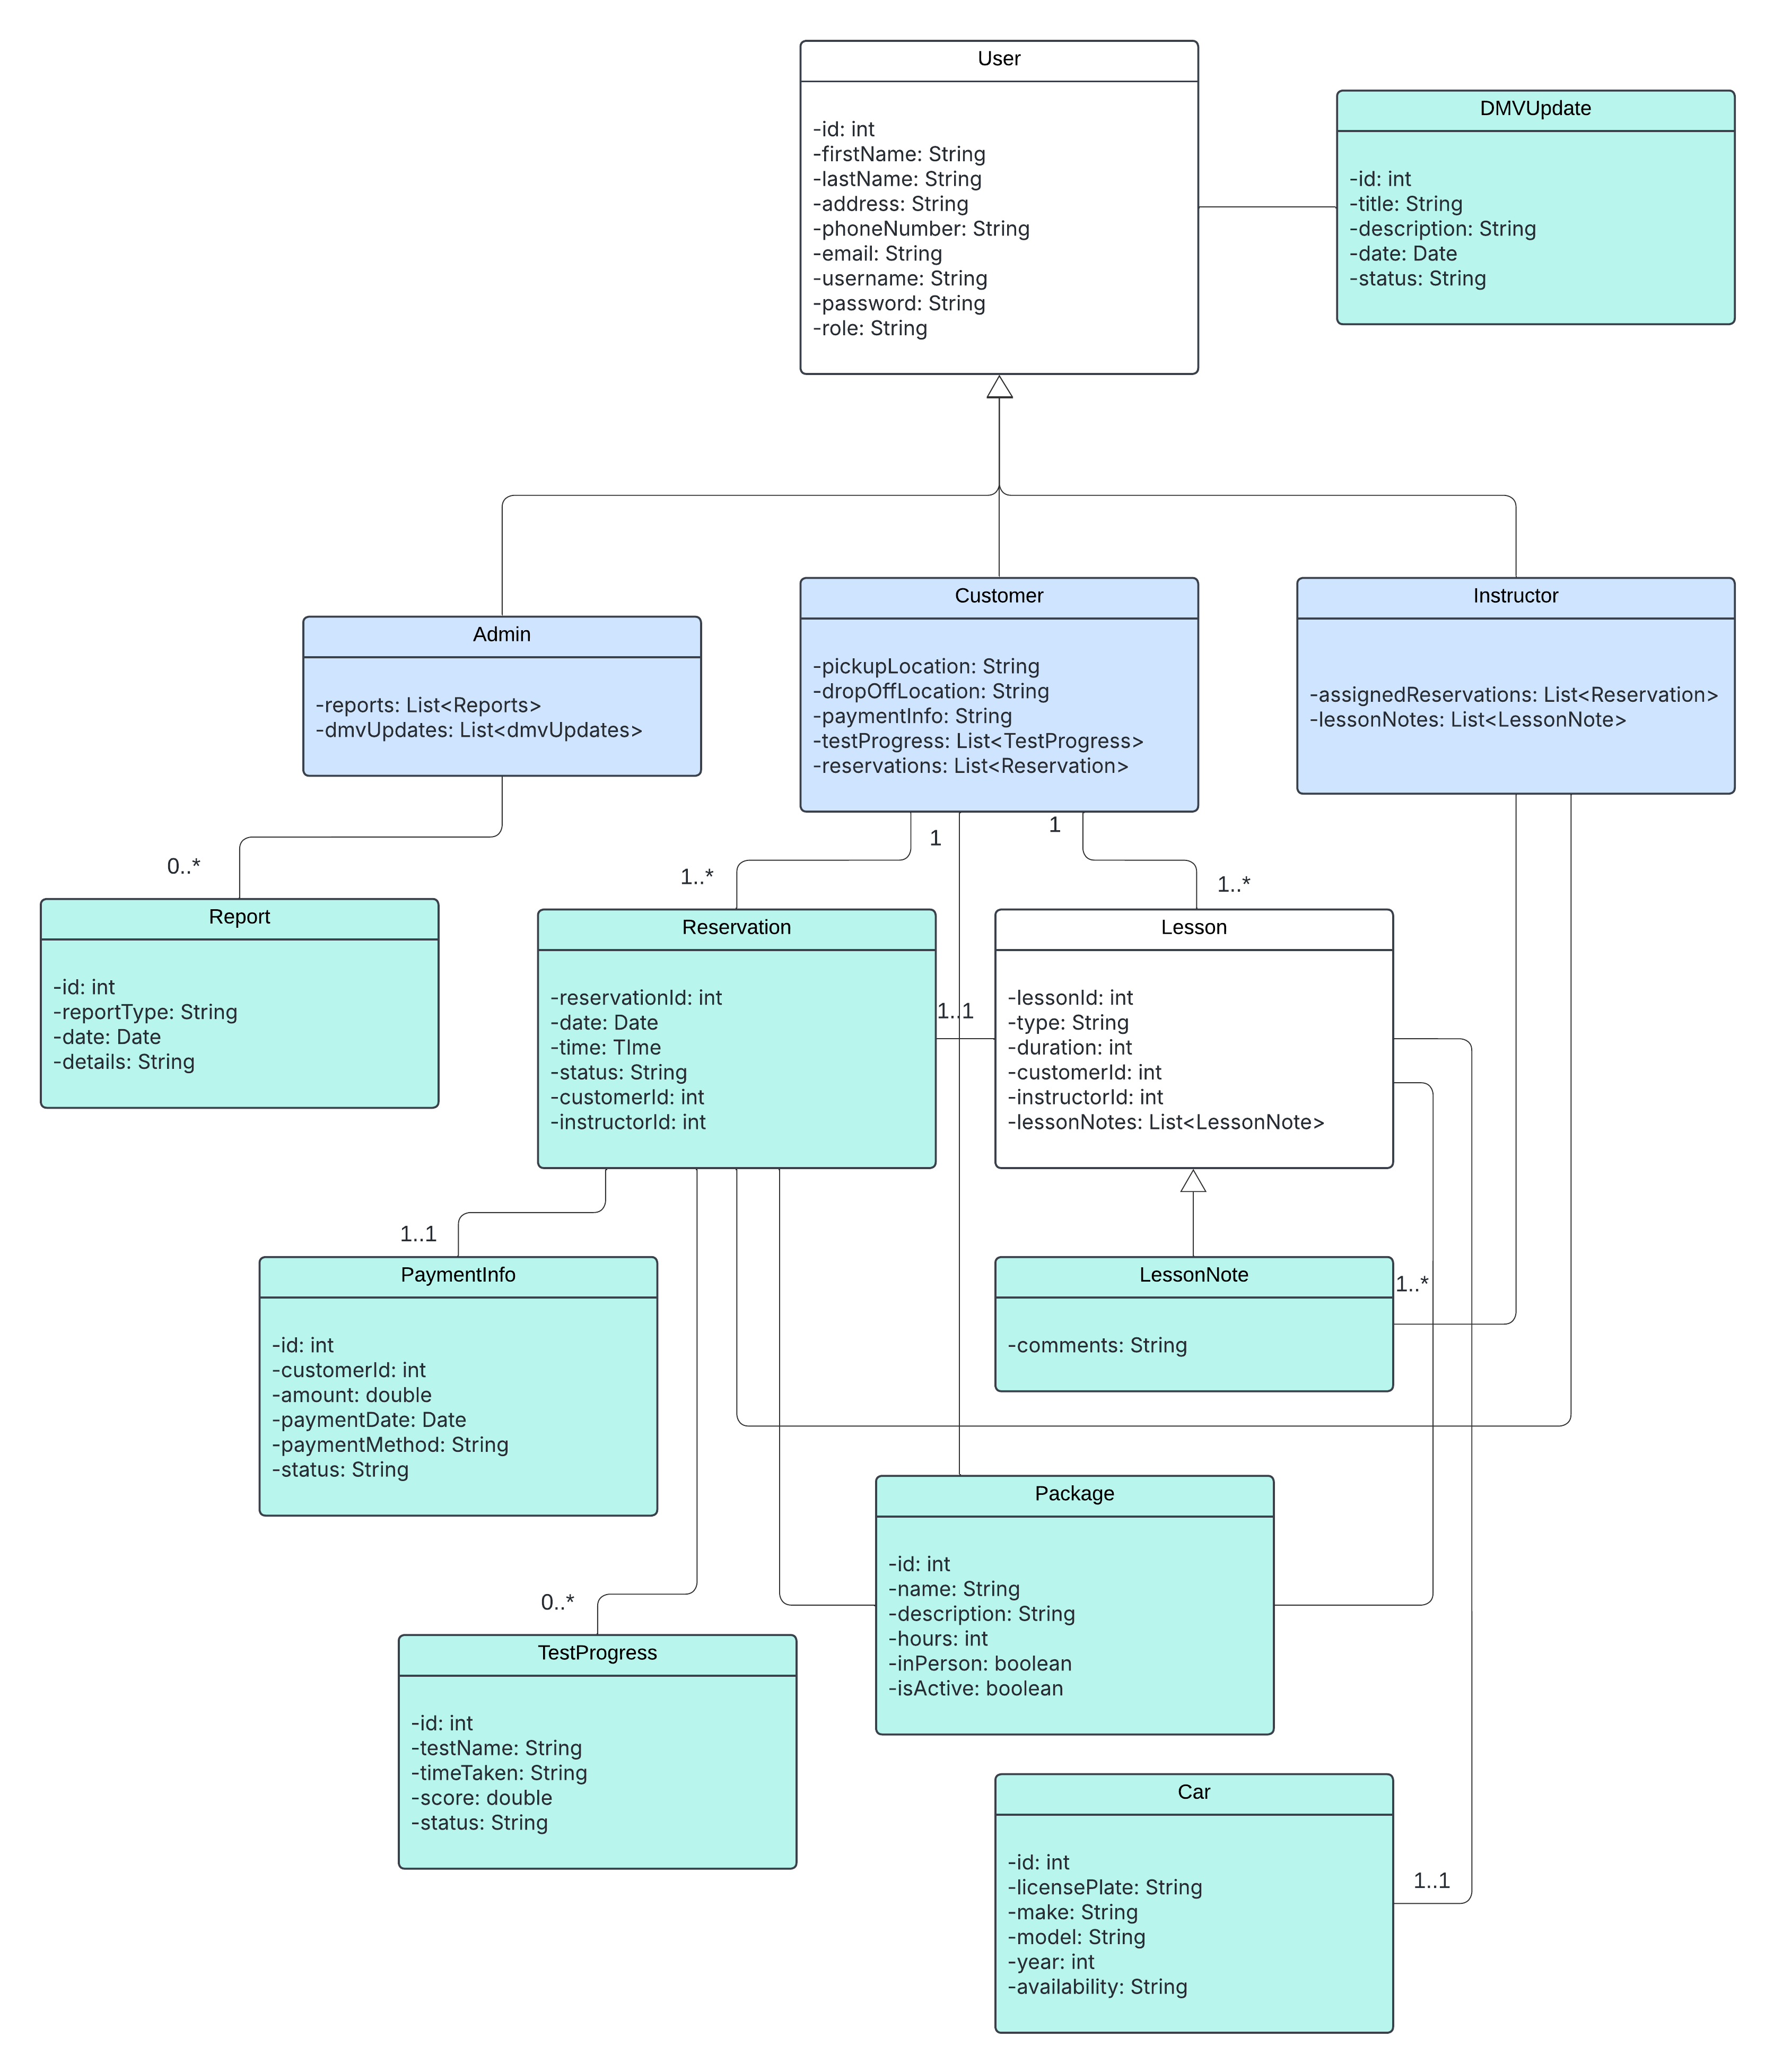

Technical Requirements
Hardware Requirements:

- Customer Devices
  - Desktop, laptop, or mobile devices to access the system
- Network
  - Reliable internet connection for uninterrupted access to the system

Software Requirements:
- Operating System
  - Linux, Windows, or another operating system
- Database Management System
  - A relational database for user accounts, payment information, and reservation data
- Hosting Service
  - A cloud hosting provider such as Amazon’s AWS or Google’s cloud platform
- Backend Development
  - System logic, user authentication, role-based access, and data management built using a chosen language
- Frontend Development
  - An interface for users to interact with the system built using a chosen language
- Email Service
  - A cloud-based email service to facilitate password resets and notify users of updates
- Authentication and Security
  - Implementation of HTTPS, security headers, cloud provider baked-in security tools, and other security measures to ensure robust system security

Tools and Infrastructure:
- Backups and Recovery
  - Automated data backups and establish a recovery procedure
- Monitoring and Logging
  - Use cloud monitoring services such as AWS CloudWatch for performance metrics and to issue alerts
- CI/CD
  - Utilize cloud CI/CD tools for automated deployment and updates

